**Literature Survey on Smart Fashion Recommender Application**

TEAM ID: PNT2022TMID11721

PROJECT NAME: Smart Fashion Recommender Application

# Abstract:

* In recent years, the textile and fashion industries have witnessed an enormous amount of growth in fast fashion.
* On e-commerce platforms, where numerous choices are available, an efficient recommendation system is required to sort, order, and efficiently convey relevant product content or information to users.
* Image-based fashion recommendation systems (FRSs) have attracted a huge amount of attention from fast fashion retailers as they provide a personalized shopping experience to consumers.
* With the technological advancements, this branch of artificial intelligence exhibits a tremendous amount of potential in image processing, parsing, classification, and segmentation.

# Introduction:

* According to different studies, e-commerce retailers, such as Amazon, eBay and social networking sites, such as Pinterest, Snapchat, Instagram, Facebook, are now regarded as the most popular media for fashion advice and recommendations
* Chatbots, sometimes referred to as intelligent assistants, are one of the most significant roles that artificial intelligence is now playing in the fashion business.
* Chatbots are actual computer programmers that can manage a conversation by exchanging text or voice messages, emulating intelligent human dialogues.
* They gradually hone their ideas and talents using a combination of visual AI and machine learning.

Phases of Recommendation Process:

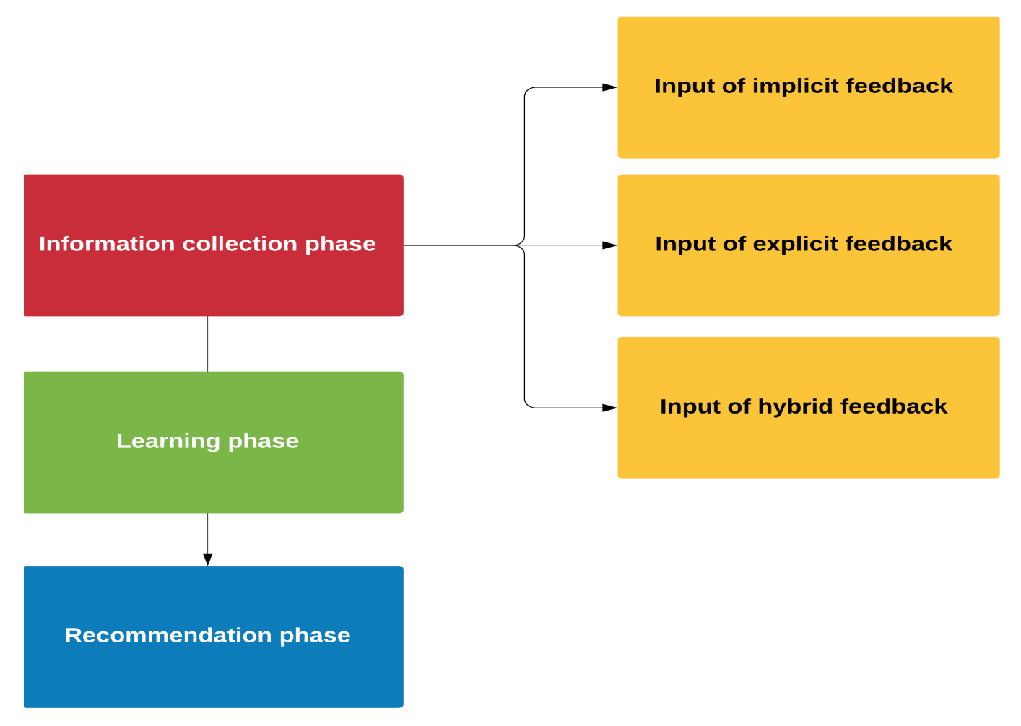

#### **Information Collection Phase**

* In this phase a user’s relevant information is collected to develop a user profile or model based on the user’s characteristics, behaviors, and the content of the resources they have browsed, which are applicable in prediction phase tasks.
* The accurate functioning of a recommendation agent depends on the proper construction of a user profile or model. The system can offer a quick yet appropriate recommendation when it has all the required information about the user.
* Thus, the success of a recommendation or recommender system largely depends on the ability of the model to denote users’ current preferences or choices

#### **Learning Phase**

* A learning algorithm is applied in this phase to filter and exploit the users’ features based on the feedback collected in the information collection phase.
* The learning algorithms used in this phase are helpful for drawing out the appropriate patterns relevant for application during the recommendation stage

#### **Recommendation Phase**

* The recommendation phase recommends the types of items that a user or consumer may prefer.
* Recommendations can be provided either directly based on the dataset collected during the information collection phase (which might be memory- or model-based) or through the browsing history of users observed by the system.
* Recommendations can also be provided by combining the learned information with the rating matrix to recommend learning resources.

## Conclusion:

* Unconscious fashion purchases, triggered by marketing strategies that do not engage the customer in a conscious and sustainable consumption, but only stimulate demand through the continuous launch of new garment collections, have defined success in terms of the turnover of the industry to the detriment of both the environment and the community.
* However, to survive this pandemic and emerge stronger, fast fashion retailers must integrate sustainability into their new growth strategies. In the post-COVID- 19 pandemic world, trends demonstrate that the “new mindful customer” will priorities trust and purpose and will likely evaluate firms based on how they acted in terms of sustainability practices during and after the crisis. Transparency will be extremely relevant for all interested parties.
* It may not be easy to manage a one-off economic crisis by generating mindful actions in favor of environmental and social concerns. For this reason, the new MSC approach could help marketing managers rebuild a more sustainable fast fashion industry

## References:

* *Amel, E., Manning, C., & Scott, B. (2009). Mindfulness and Sustainable Behaviour: Pondering Attention and Awareness as Means for Increasing Green Behaviour. Ecopsychology, 1, 14−25.* [*https://doi.org/10.1089/eco.2008.0005*](https://doi.org/10.1089/eco.2008.0005)
* *Anguelov, N. (2015). The Dirty Side of the Garment Industry: Fast Fashion and Its Negative Impact on Environment and Society (1st ed.). CRC Press.* [*https://doi.org/10.1201/b18902*](https://doi.org/10.1201/b18902)
* *Aspy, D. J., & Proeve, M. (2017). Mindfulness and Loving-Kindness Meditation: Effects on Connectedness to Humanity and to the Natural World. Psychological Reports, 120(1), 102−117.* [*https://doi.org/10.1177/0033294116685867*](https://doi.org/10.1177/0033294116685867)
* *Badham, R., & King, E. (2021). Mindfulness at work: A critical re-view. Organization, 28(4), 531−554.* [*https://doi.org/10.1177/1350508419888897*](https://doi.org/10.1177/1350508419888897)
* *Baer, R. A. (2003). Mindfulness training as a clinical intervention: A conceptual and empirical review. Clinical Psychology: Science and Practice, 10(2), 125−143.* [*https://doi.org/10.1093/clipsy.bpg015*](https://doi.org/10.1093/clipsy.bpg015)